Lab-1 (RA1911003010917)

Hour Glass Puzzle

//INPUT//

R = 5

C = 5

def MaxSum(arr):

max_sum = -50000

if(R < 3 or C < 3):

return -1

for i in range(0, R-2):

for j in range(0, C-2):

SUM = (arr[i][j] + arr[i][j + 1] + arr[i][j + 2]) + (arr[i + 1][j + 1]) + (arr[i + 2][j] +

arr[i + 2][j + 1] + arr[i + 2][j + 2])

if(SUM > max_sum):

max_sum = SUM

else:

continue

return max_sum

arr = [[1, 2, 3, 0, 0],

[0, 0, 0, 0, 0],

[2, 1, 4, 0, 0],

[0, 0, 0, 0, 0],

[1, 1, 0, 1, 0]]

res = MaxSum(arr)

if(res == -1):

print("Not possible")

else:

print(f"Maximum sum of hour glass = {res}")

//OUTPUT//

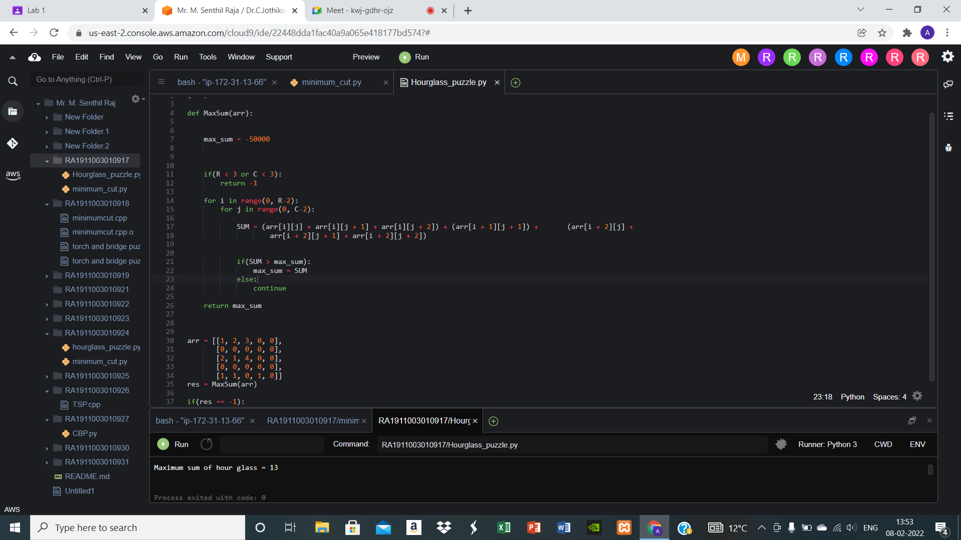

Minimum Cut

//INPUT//

import math

# Function to find the minimum

# number of cuts to pay the worker.

def pay(n):

# Nearest Integer to the Log

# value of the number N

cuts = int(math.log(n, 2))

return cuts

# Driver Code

if __name__ == "__main__":

n = 5

cuts = pay(n)

print(cuts)

# Cuts Required in the

# Length of 15

n = 15

cuts = pay(n)

print(cuts)

//OUTPUT//

